EPO-DVO



User Guide for EPO-DVO Application Administrators

Version 1.0

April 22, 2009

Revision History
Revision History
Document Version | Date | Name | Comments
1.0 | 04/21/09 | Julie Franklin | Creation of first draft of document
1.0 | 04/22/09 | Janet Frazier | Revision of first draft of document

Sign-Off
Sign-off Level | Date | Name | Signature
Level 1
Level 2

Table of Contents
Revision History 3
Table of Contents 4
1.0 Introduction 5
2.0 Assigning New User Roles 6
2.1 Assigning the Role 6
2.1.1 Searching with Partial Names 12
3.0 Assigning / Removing a User Role 15
3.1 Adding a User Role 18
3.2 Removing a Role 20
3.2.1 Using the Users in Role List to Remove a Role 22
4.0 Appendix 25
4.1 Assigning New User Security Role Work Flow 25
4.2 Removing User Role from Existing User Work Flow 28
4.3 Adding User Role to Existing User Work Flow 31

1.0 Introduction
CHFS administrators use the CHFS Security Portal Administration application to assign user security roles to new EPO-DVO application users. No user can access the application unless he is assigned the correct user role.
Table 1: User Security Roles
User Security Roles
Role | Description
CHFS Admin | Assign or revoke privileges to the EPO-DVO application  Search EPO-DVO database to view active or expired orders
Case Manager | Search EPO-DVO database to view active or expired orders
CHFS Administrators can also update user security roles for existing users, adding or removing them as necessary.
This user guide discusses the CHFS administrator’s role in relation to the EPO-DVO application.
- Assigning new user security roles
- Updating existing user security roles

2.0 Assigning New User Roles
CHFS administrators must assign the correct user security role to the newly-approved user.
CHFS administrators can access the CHFS Security Portal Administration application from a link on the EPO-DVO Search by Name page. This link is only available to those individuals who have been assigned the CHFS Admin user security role.
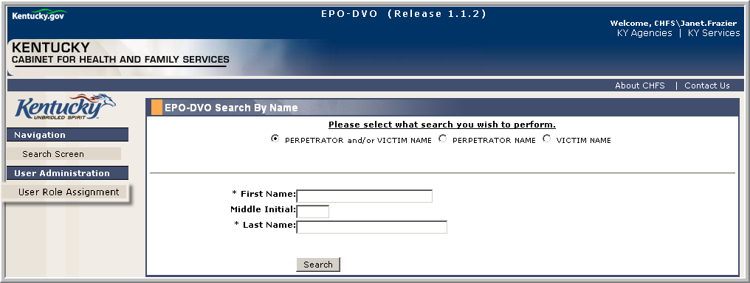
Figure 2.0.1 – EPO-DVO Search by Name Page

2.1 Assigning the Role
An individual applying for EPO-DVO access must complete all required documents.
- EPO/DVO Application Access Request
- CHFS – 219 Security Agreement
Begin the user role assignment by verifying that the required documents have been correctly completed and returned to you.
- Use your network ID to log into the EPO-DVO application.
- Click the User Role Assignment link to open the Security Portal Administration application.
Figure 2.1.1 – EPO-DVO Search by Name Page
Tip: The Security Portal Administration application opens in a second browser window.
- Click the User – Assign Roles link.
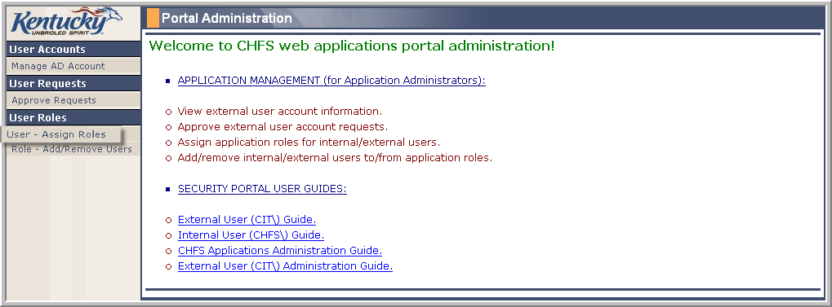
Figure 2.1.2 – Portal Administration Page
- Enter the necessary search criteria. Search with first and last names or with the user name. You may conduct a search with partial names. See Section 2.1.1 for a complete discussion of the steps necessary to search with partial names.
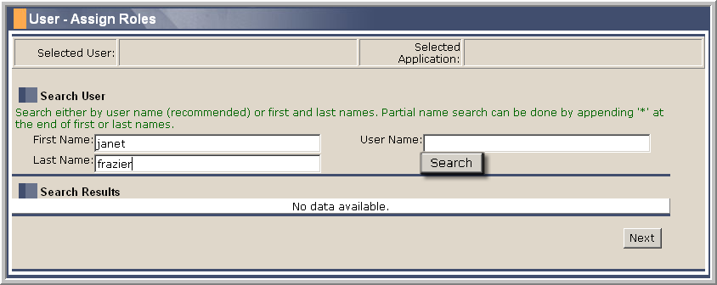
Figure 2.1.3 – User – Assign Roles Page
- Click the Search button or the Enter key on the computer keyboard.
- The Security Portal Administration application notifies you if there are no search results.
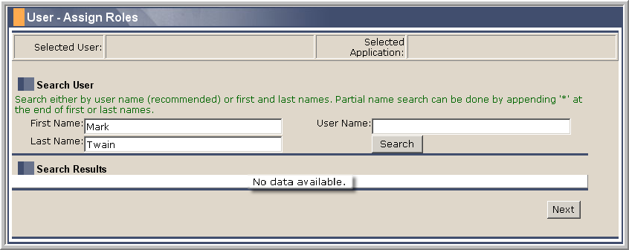
Figure 2.1.4 – No Search Results Notice
- Click the Select link at the beginning of the individual’s grid row.
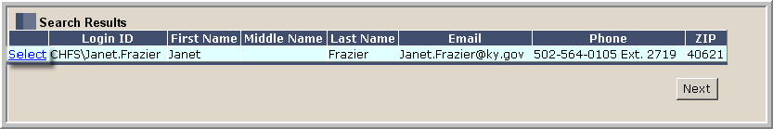
Figure 2.1.5 – Search Results
- Click the EPO-DVO radio button to select the application you are working with. (The Security Portal Administration application can be used to assign user roles for multiple applications.)
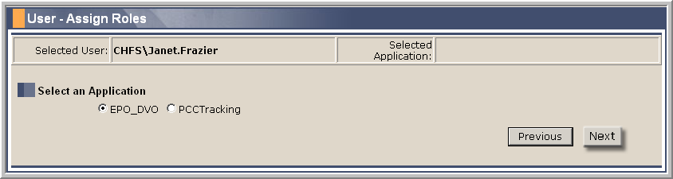
Figure 2.1.6 – Select an Application
- Click the Next button to move to the next page.
Tip: Click the Previous button to return to the previous page.
- Click the check box next to the user role you want to assign.
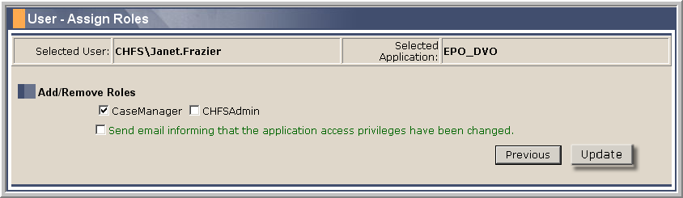
Figure 2.1.7 – Assign User Roles
Tip: Assign the CaseManager role to all users; only application administrators are assigned the CHFSAdmin role.
- Click the Update button to update the assignment.
- The Security Portal Administration application notifies you of the successful update.
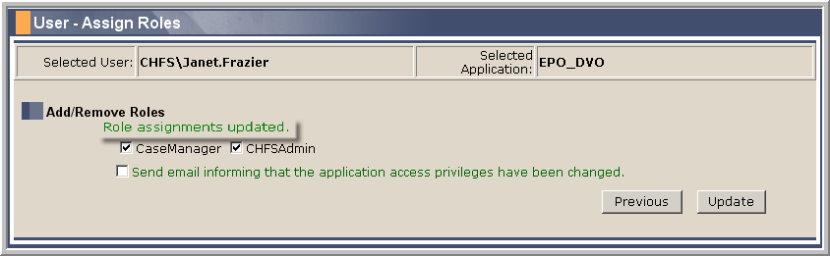
Figure 2.1.8 – Update Notice
- Close the Security Portal Admin browser window.
- Click the Search Screen link to return to the EPO-DVO Search by Name page.
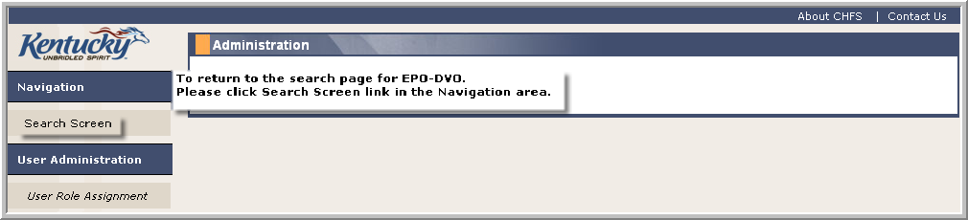
Figure 2.1.9 – Search Screen Link

2.1.1 Searching with Partial Names
The Security Portal Administration application enables you to conduct a wildcard search using partial names combined with the asterisk (*) symbol that produces all names beginning with your search elements. (A wildcard is a character that may be combined with a search element to represent one or more other characters.)
- Use your network ID to log into the EPO-DVO application.
- Navigate to the Search User page of the Security Portal Administration application. See Section 2.1 for a complete discussion of the steps necessary to navigate to the Search User page.
- Enter at least the first two letters of the first name, followed by an asterisk (*). (You must use the asterisk symbol when you are constructing a wildcard search: a search using only the partial name produces no results.)
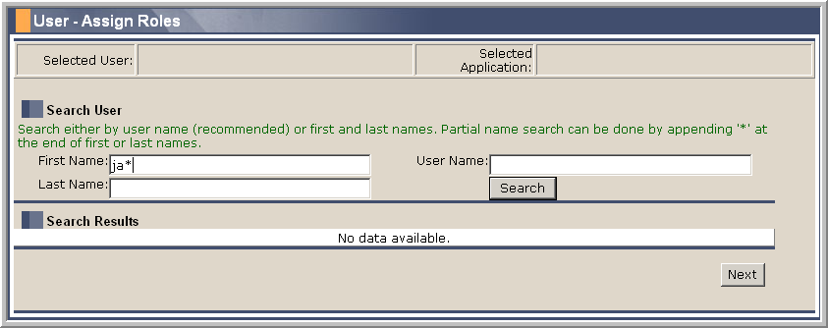
Figure 2.1.1.1 – Partial First Name Entry
- Enter at least the first two letters of the last name, followed by an asterisk (*).
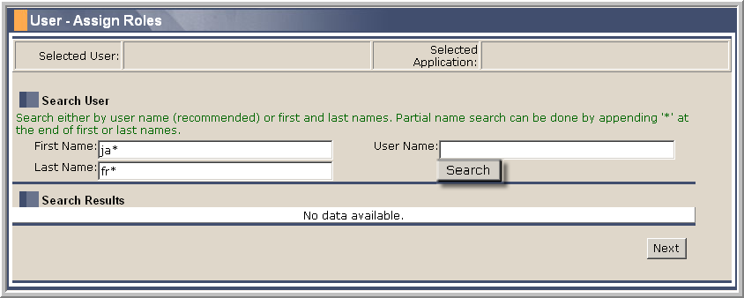
Figure 2.1.1.2 – Partial Last Name Entry
- Click the Search button or the Enter key on the computer keyboard.
- The search produces all results beginning with the entered search criteria.
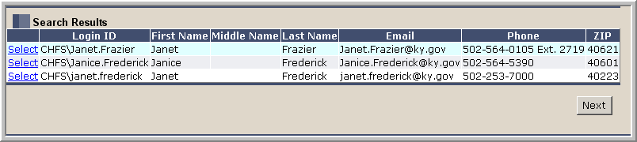
Figure 2.1.1.3 – Search Results
- Click the Select link next to the necessary search result to continue with the user role assignment process. See Section 2.1 for a complete discussion of the step necessary to assign user roles.

3.0 Assigning / Removing a User Role
The Security Portal Administration application enables application administrators to assign security roles to existing users, or to remove them when necessary. Begin the process by locating the user whose security roles must be modified.
- Use your network ID to log into the EPO-DVO application.
- Click the User Role Assignment link to open the Security Portal Administration application.
Figure 3.0.1 – EPO-DVO Search by Name Page
Tip: The Security Portal Administration application opens in a second browser window.
- Click the Role – Add/Remove Users link.
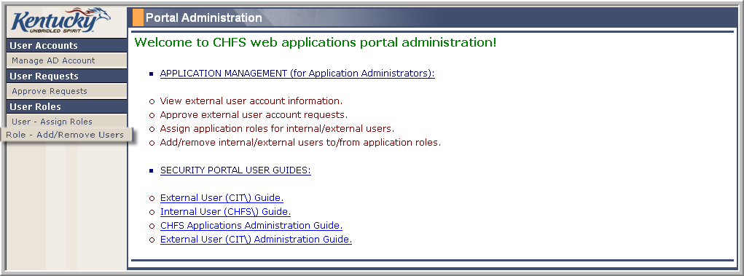
Figure 3.0.2 – Portal Administration Page
- Click the EPO-DVO radio button to select the application you are working with.
- Click the Next button.
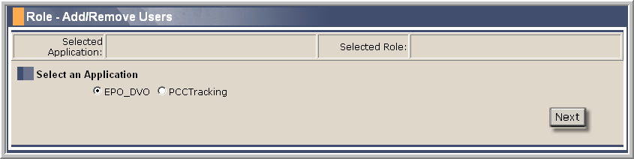
Figure 3.0.3 – Application Selection
- Click the radio button next to the role you wish to remove.
- Click the Next button.
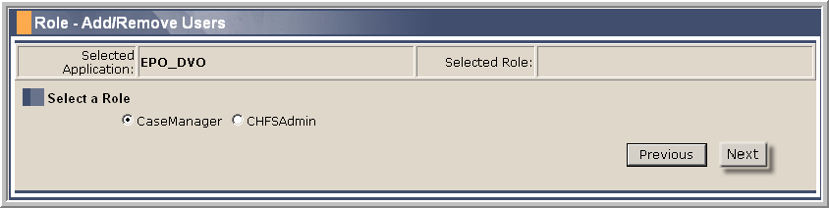
Figure 3.0.4 – Selecting Role
Tip: Click the Previous button to return to the previous page.
- Enter the user search criteria. You must enter both the first and last names, or the user name. You may search with partial names. See Section 2.1.1 for a complete discussion of the steps necessary to search with partial names.
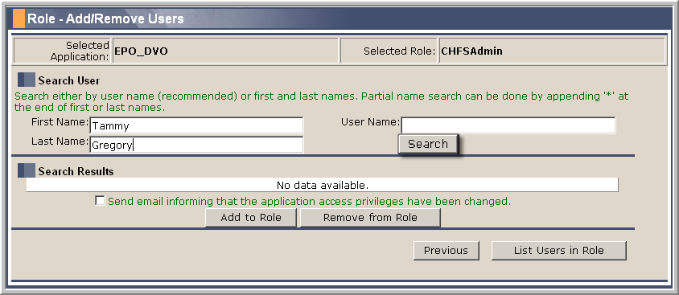
Figure 3.0.5 – User Search Criteria
- Click the Search button or the Enter key on the computer keyboard.
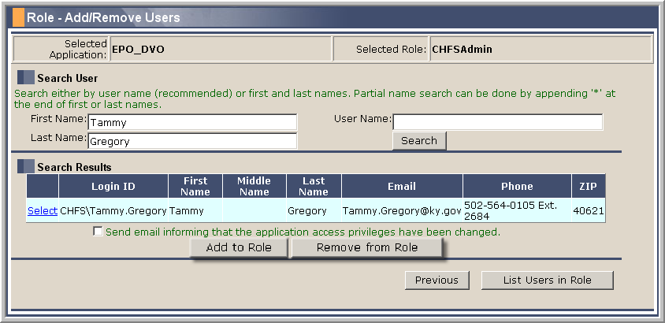
Figure 3.0.6 – Search Results
- Click the Select link next to the appropriate name to select the individual to be removed from the user role. The application highlights the selected row.
At this point in the process, you may opt to add or remove the security role.

3.1 Adding a User Role
You may add a user role to an existing user. (See Section 3.2 to remove a user security role.)
- Click the Add to Role button.
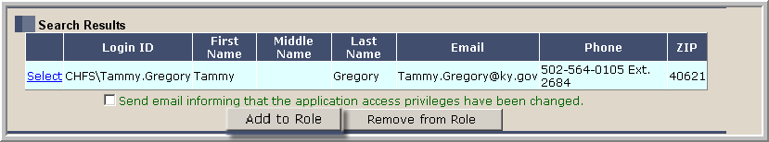
Figure 3.1.1 – Add to Role Button
- The Security Portal Administration application notifies you that the individual is added to the user role.
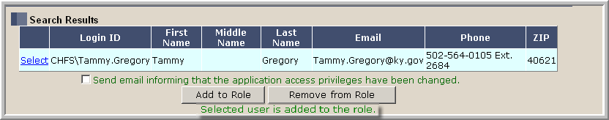
Figure 3.1.2 – User Added to Role Notice
- Click the List Users in Role button to verify that the user has been added to the listed users.
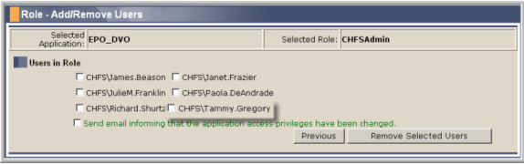
Figure 3.1.3 – User Added to Users in Role List
- Close the Security Portal Administration application.
- Click the Search Screen link if it is necessary to return to the EPO-DVO Search by Name page.
Figure 3.1.4 – Search Screen Link

3.2 Removing a Role
You may choose to remove a user role from the user.
- Click the Remove from Role button.
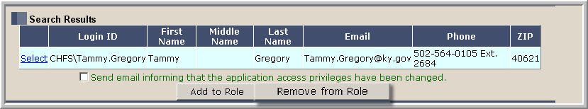
Figure 3.2.1 – Remove from Role Button
- The Security Portal Administration application notifies you that the individual is removed from the user role.
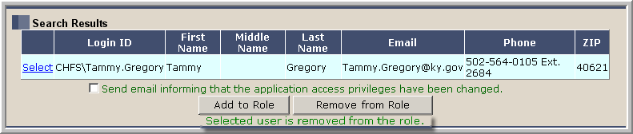
Figure 3.2.2 – User Removed from Role Notice
- Click the List Users in Role button to verify that the user has been removed from the listed users.
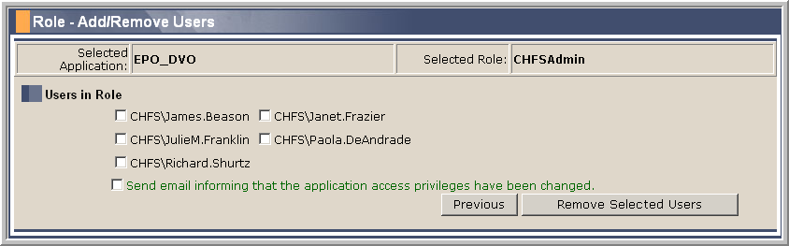
Figure 3.2.3 – User Removed from Users in Role List
- Close the Security Portal Administration application.
- Click the Search Screen link if it is necessary to return to the EPO-DVO Search by Name page.
Figure 3.2.4 – Search Screen Link

3.2.1 Using the Users in Role List to Remove a Role
You can also remove a user from a user role by going directly to the Users in Role list.
- Locate the user to be removed from a user role. See Section 3.0 for a complete description of the steps necessary to locate the user.
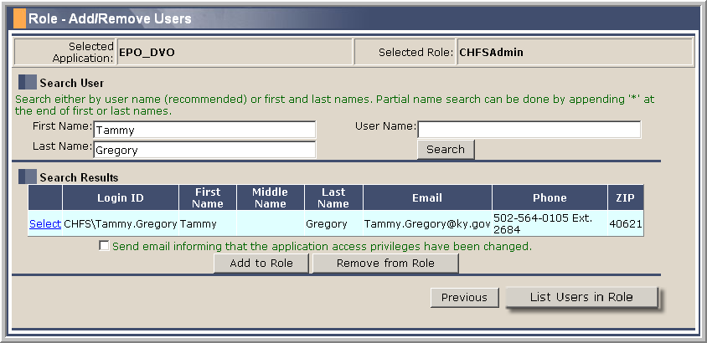
Figure 3.2.1.1 – Search Results Grid
- Click the List Users in Role button to show all users assigned to the role.
- Click the check box next to the name of the user to be removed.
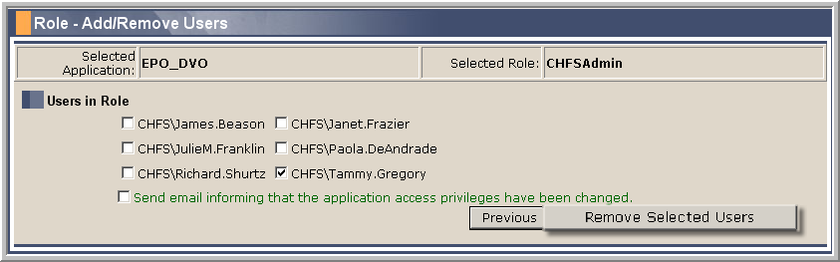
Figure 3.2.1.2 – Remove User
- Click the Remove Selected Users button to remove the user name from the Users in Role list.
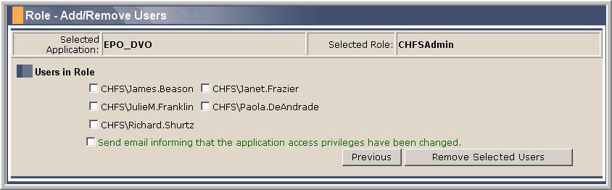
Figure 3.2.1.3 – User Removed
- Close the Security Portal Administration application.
- Click the Search Screen link to return to the EPO-DVO Search by Name page.
Figure 3.2.1.4 – Search Screen Link

4.0 Appendix

4.1 Assigning New User Security Role Work Flow
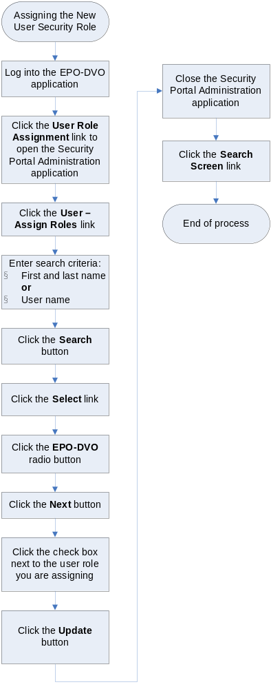

4.2 Removing User Role from Existing User Work Flow
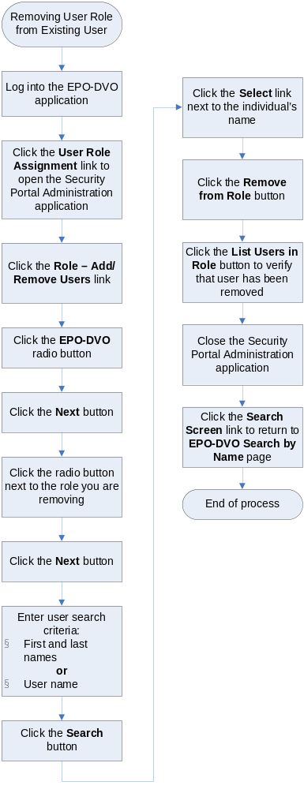

4.3 Adding User Role to Existing User Work Flow


